# PROJECT DEVELOPMENT PHASE SPRINT -3

|  |  |
| --- | --- |
| Date | 02-11-2022 |
| Team ID | PNT2022TMID14052 |
| Project Name | Real-Time River Water Quality Monitoring and Control System |
| Marks |  |

SPRINT DESCRIPTION

In this Sprint we are about to describe about the Application we have developed and the Final Testing of the Python Code.

PYTHON EXECUTED OUTPUT

We have successfully developed the python code and executed it. The code runs with the Temperature, Humidity and pH Value also displayed in the IBM IoT Platform.

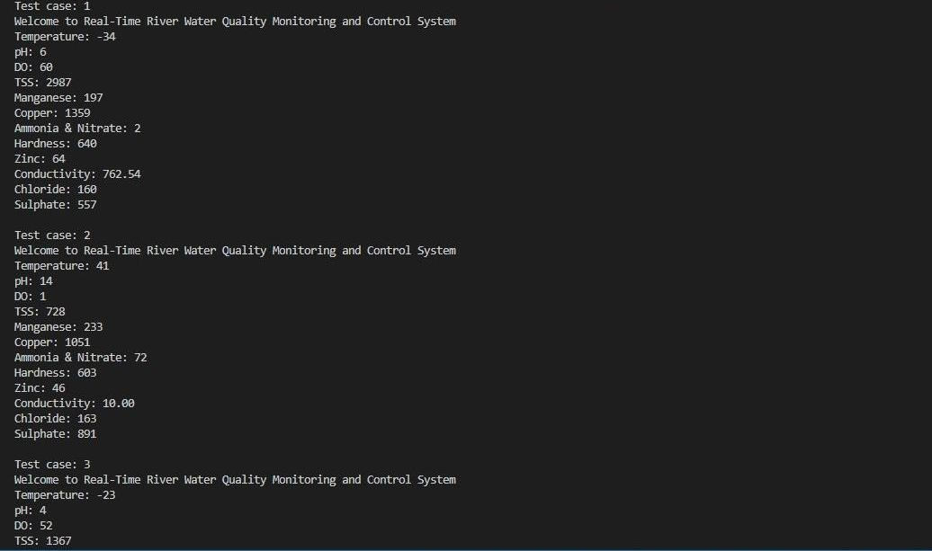

# APPLICATION SCREENS

HERE WE DISPLAYED SCREEN 1 & SCREEN 2 PAGES OF OUR CREATED APPLICATION

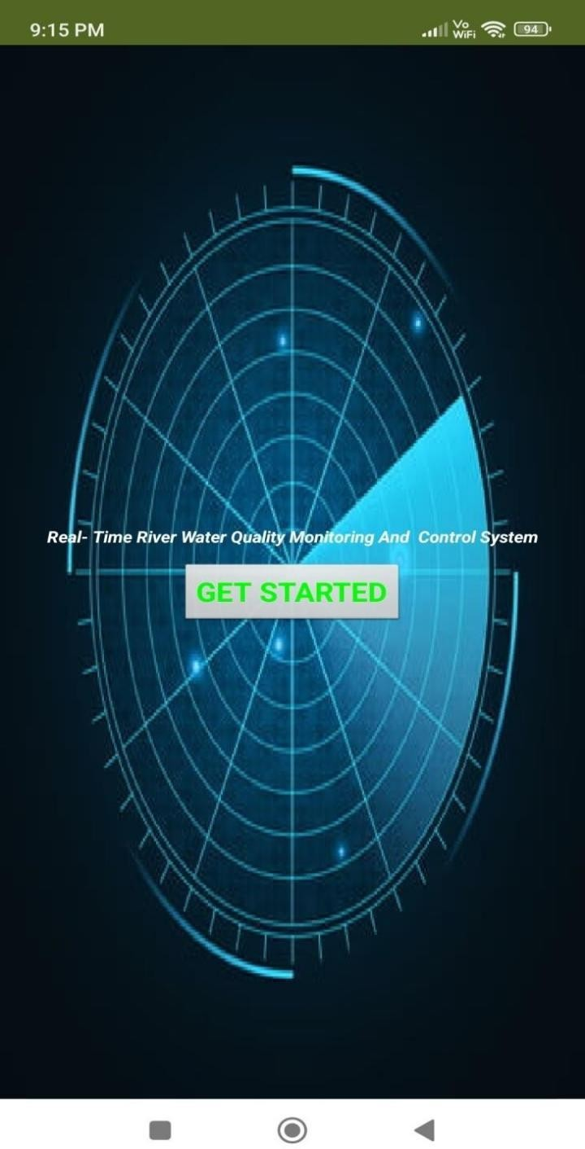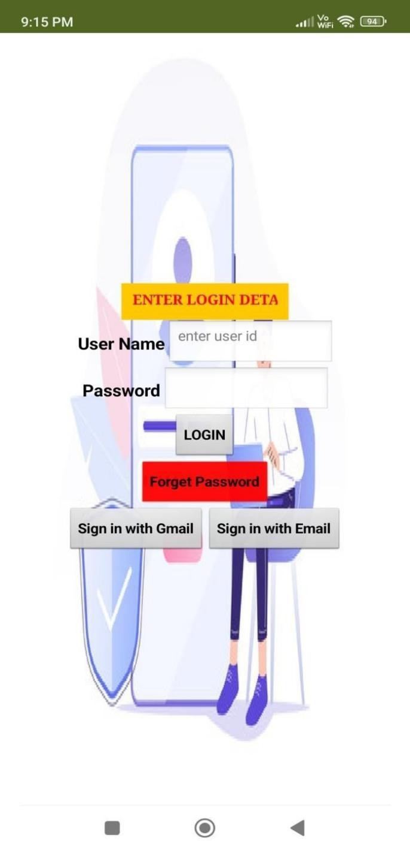

HERE WE DISPLAYED SCREEN 3 & SCREEN 4 OF OUR CREATED APPLICATION

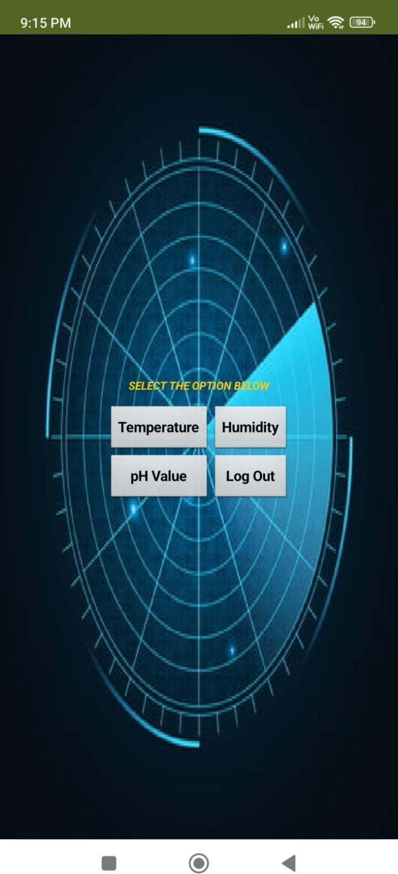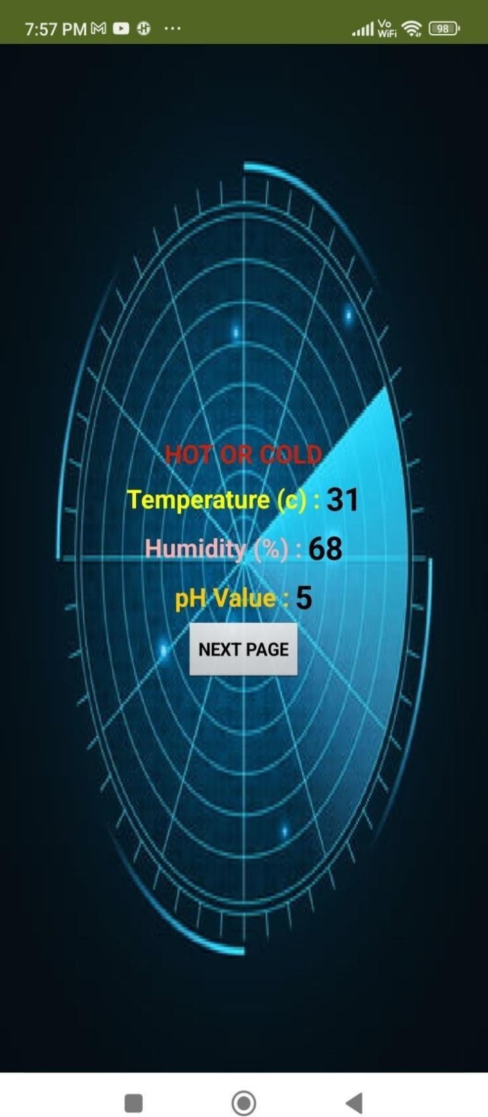

HERE WE DISPLAYED SCREEN 5 & SCREEN 6 OF OUR CREATED APPLICATION

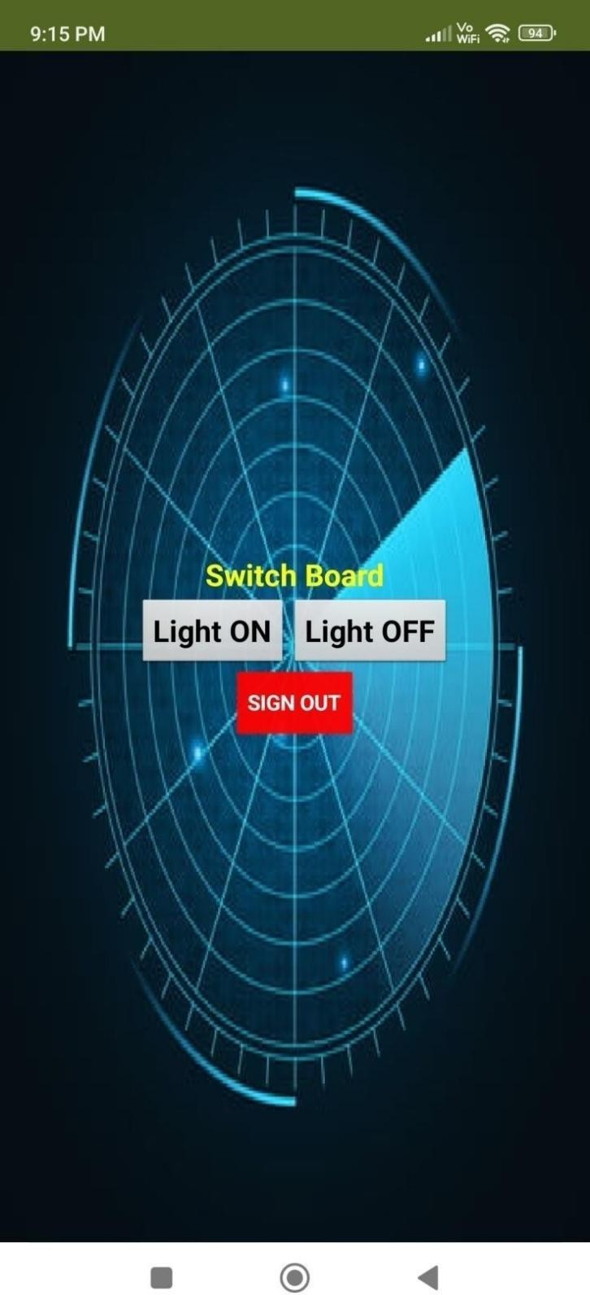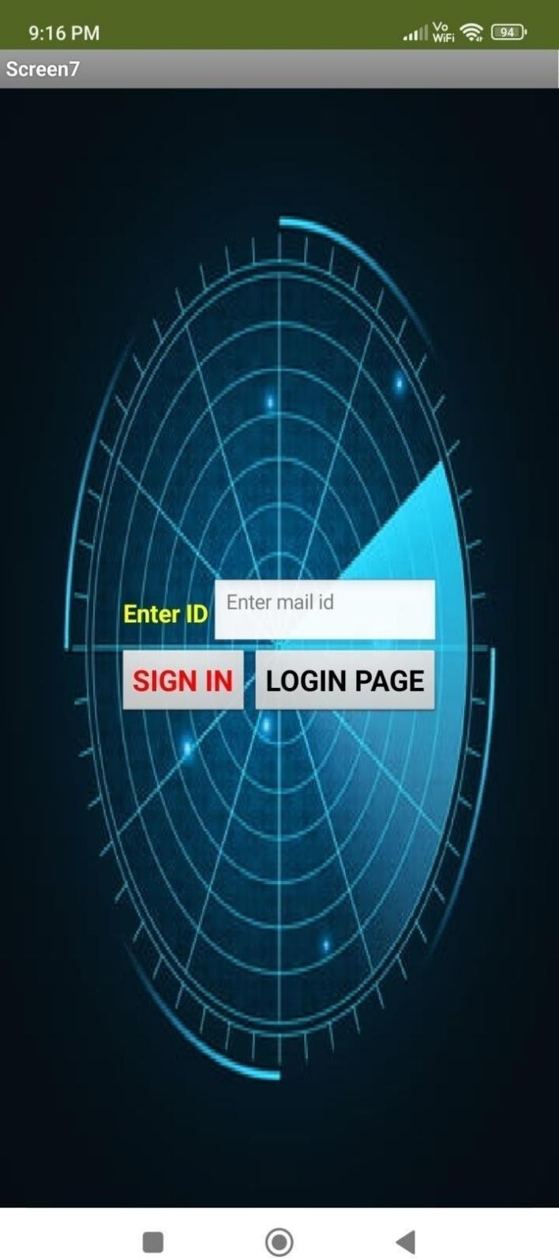

# BLOCKS FUNCTIONS USED IN OUR APPLICATION

SCREEN 1 & SCREEN 2

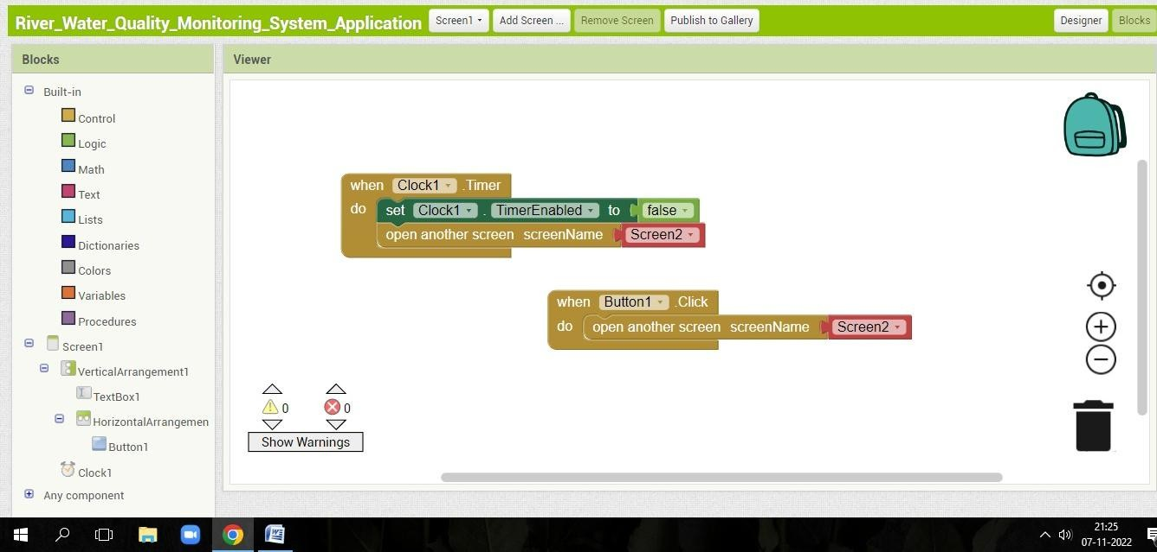

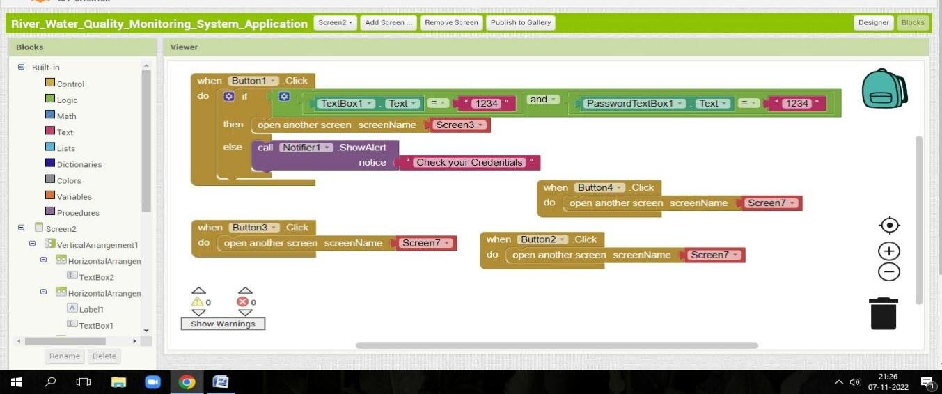

SCREEN 3 & SCREEN 4

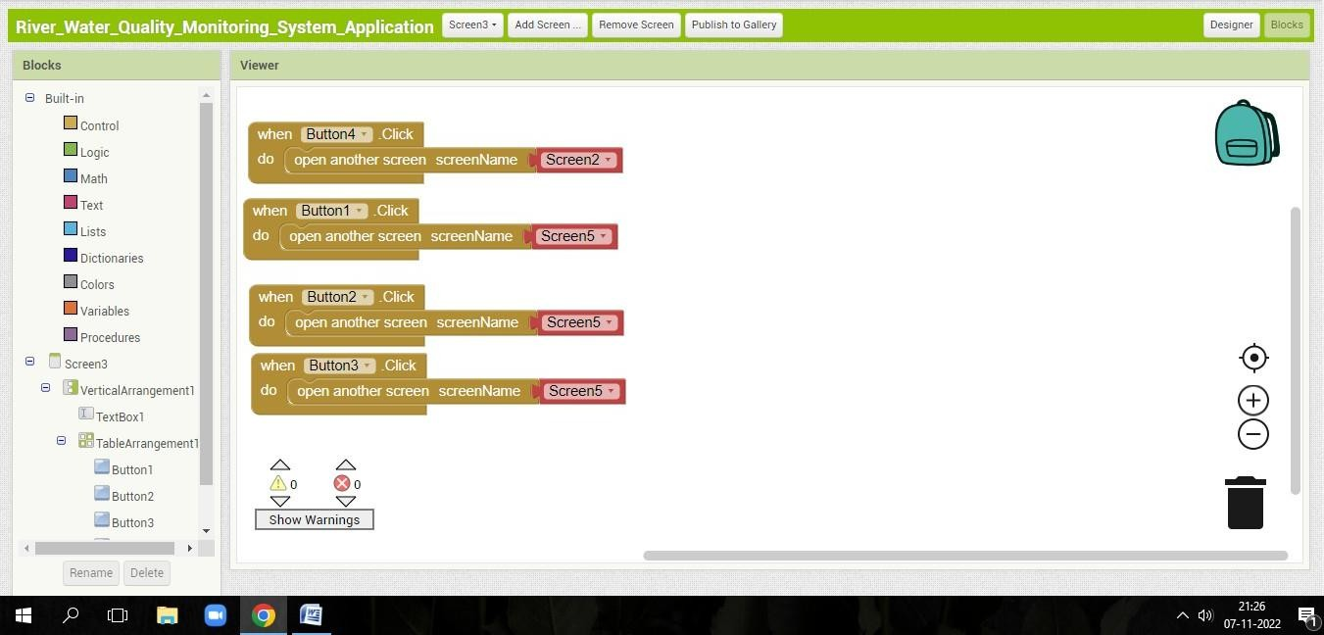

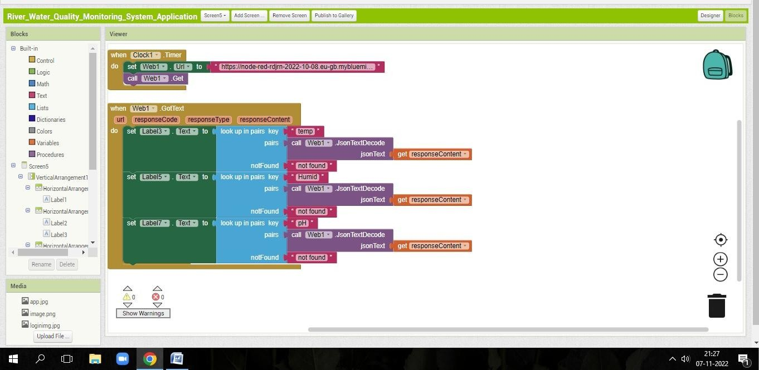

SCREEN 5 & SCREEN 6

